**Git Developer notes**

1. **Request an issue** – email [cmsupport@usf.edu](mailto:cmsupport@usf.edu) using this format below.

Note: repository names will be the same as the JIRA project names

(OASBAN, OASAM, AISDW, ABSFAM, ABSGAM, FAAM, etc.).

**Please create an issue:**

**Project/Repository:** OASIS Banner Development (OASBAN)

**Issue Type:** Improvement, Fix, etc.

**Project/Issue number:**  12-0232

**Description:** SSFAD DER maintenance

**Technical Manager:** Praveen Sadagopan

1. **Work on an issue** –

From Z🡪github🡪developers right click checkoutissue.shl, highlight & click gitbash, type checkoutissue.shl in the gitbash window and hit enter. You are then prompted for the issue number. Enter the issue number (i.e. oasban.#1) – repository name, dot/period, pound sign, issue number (format is very important). Example below shows issue testrepr.#2:

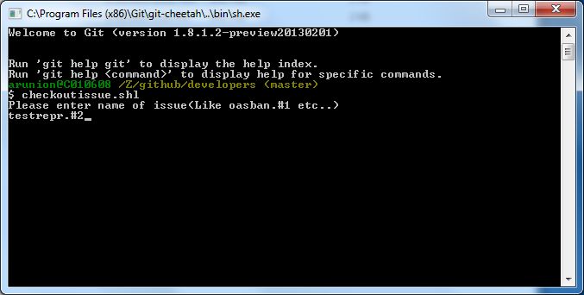

To verify, go to C🡪github🡪oasban (or whatever the repository name is) right click and point your mouse on git branch and it should show the issue name (i.e. oasban.#1).

1. **Modify code -** Modify your code and save under c:\repositoryname\objecttype (i.e. c:\oasban\dbprocs).
2. **Create shell, sql, and text files -** , create .shl file, .sql file, and .txt file and save in c:\github\repositoryname.wiki (i.e. c:\github\oasban.wiki)

**Templates are available here: Z:\github\developers\template.**

**Sample Driver Script (.sql):**

*-- University of South Florida*

*-- Banner Student System*

*-- Repository Name: testrepr*

*-- File Name : testrepr.#2.sql*

*-- File Location : c:\github\testrepr.wiki\testrepr.#2.sql.asciidoc*

*-- Description : Starts all the scripts associated with package*

*--*

*-- Software Modifications:*

*--*

*-- Version Date UserID Description*

*-- ------- --------- -------- ------------------------*

*-- 1 10/1/2013 ARUNION Initial Creation*

*----\*\*\*\*\*\*\*\*\*\*\*\*\*\*\*\*\*\*\*\*\*\*\*\*\*\*\*\*\*\*\*\*\*\*\*\*\*\*\*\*\*\*\*\*\*\*\*\*\*\*\*\*\*\*\*\*\*\*\*\*\*\*\*\*\**

SET ECHO ON

*--- existing package*

@dbprocs\wsak_adm_appl

*-- following lines needs to be added for each procedure/package*

SHOW ERROR PACKAGE baninst1.wsak_adm_appl

SHOW ERRORS package body baninst1.wsak_adm_appl

SPOOL OFF;

EXIT;

**Sample Instruction script (.txt):**

Developer: ARUNION

Project Manager: Praveen Sadagopan

# General Information

# *-------------------*

# Reposit Name : testrepr

# Issue Name : testrepr.#2

# Process Associated : git

# Object Source File Location and Name :

# c:\github\testrepr.wiki\testrepr.#2.txt.asciidoc

testrepr.#2 Issue Instructions

Objects added/modified in this issue:

dbprocs/wsak_adm_appl.sql

Instructions for DVLP:

1) Merge issue to dvlp

2) Run shell script and driver script from wiki

Instructions for PPRD:

1) Merge issue to test

2) Run shell script and driver script from wiki

Instructions for PROD:

1) Merge issue to prod

2) Run shell script and driver script from wiki

**Sample Shell script (.shl):**

#!/bin/bash

#***********************************************************************

#

# University of South Florida

# Student Information System

# Program Unit Information

#

# General Information

# *-------------------*

# Reposit Name : testrepr

# Shell Script Name : testrepr.#2.shl.asciidoc

# Process Associated : git

# Object Source File Location and Name :

# c:\github\testrepr.wiki\testrepr.#2.shl.asciidoc

# Business Logic :

# Explain business logic here.

#

#

# Audit Trail (in descending date order)

# *------------------------------------*

# Date User Reason For Change

# *--------- ------ -----------------------*

# 9/18/2013 VBANGALO Initial Creation

#

#************************************************************************

echo "Enter git Issue. (Like oasban.#1/oasban.#1.dvlp ..)."

read stage

curdir=`pwd`

cd ../testrepr

git checkout ${stage}

cd ${curdir}

if [ -d ../testrepr.#2 ]; then

rm -r -f ../testrepr.#2

fi

mkdir ../testrepr.#2

# copy procedure/packages objects

mkdir ../testrepr.#2/dbprocs

cp ../testrepr/dbprocs/wsak_adm_appl.sql ../testrepr.#2/dbprocs/

# if you have db objects, copy driver script to Issue folder

cp testrepr.#2.sql.asciidoc ../testrepr.#2/

cd ../testrepr

echo "Are you rnning this script as CM support?(yes/no)"

read resp

if [ ${resp} == "yes" ];then

git checkout master

echo "Makesure branch is on master"

read branch

fi

**(5) Create issue folder -**

Run .shl to create issue folder under c🡪github

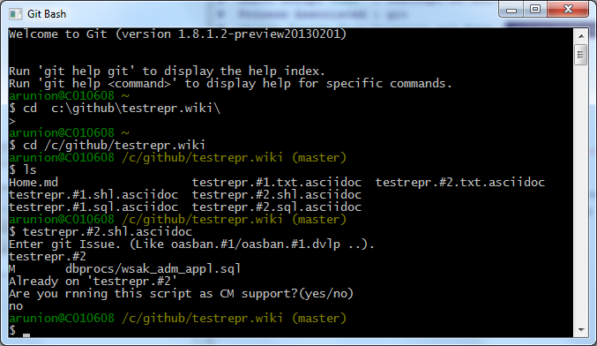

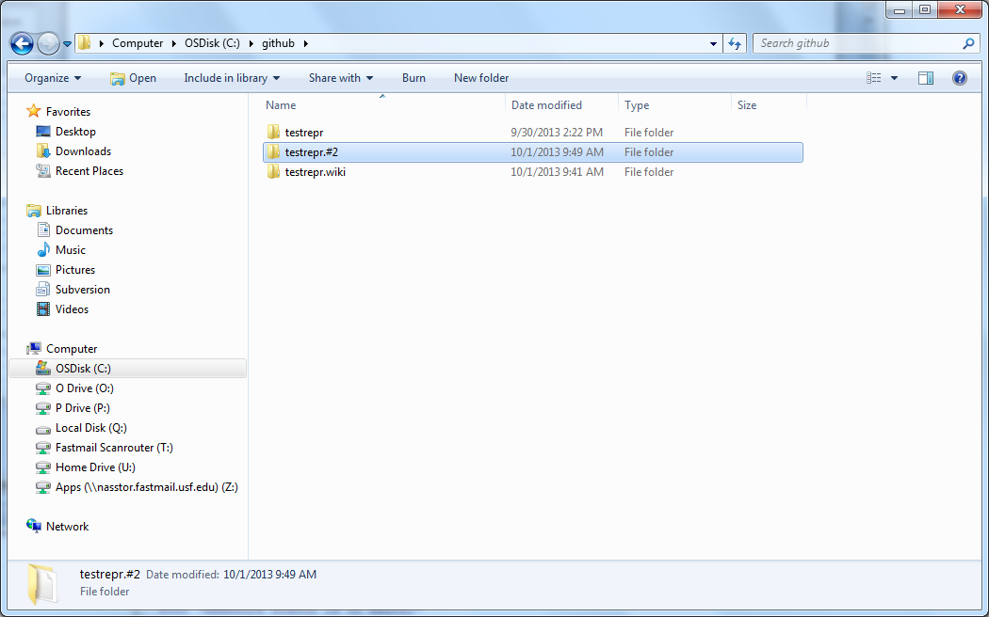

1. **Compile/Test -**

Compile/test code/check for errors. (Open command window and load testrepr.#2.sql.asciidoc that is under c:\github\testrepr.#2 folder)

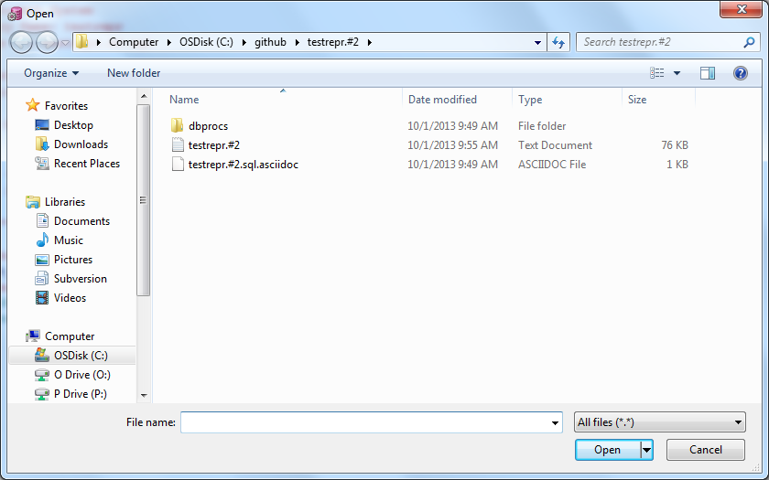

1. **Commit code –**commit the code - open c:\github\testrepr.wiki in gitgui, put message "added .txt, .shl, .sql", click on stage changed and yes to ‘stage untracked files’ , click on commit, click push

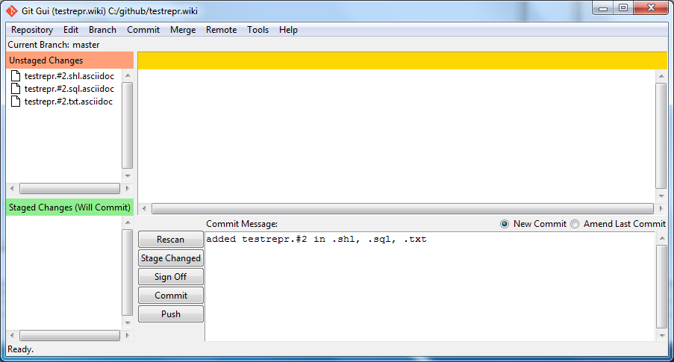

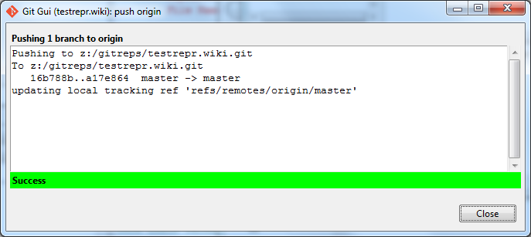

In c:\github\testrepr open gitgui and click on Stage Changed

Add commit message: "#2 changed wsak_adm_app for issue…..l" and click on commit

Click on Push

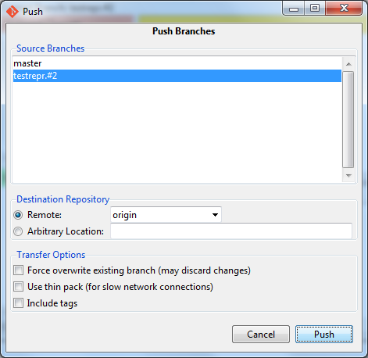

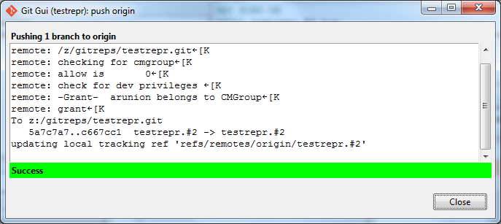

1. **Request code to be promoted –**

email [cmsupport@usf.edu](mailto:cmsupport@usf.edu) and ask them to promote to ready for DVLP/TEST/etc.